Comp 8006 Assignment 2

Network Emulator

By: Peyman

peymantparsa@gmail.coms

& John Warren

For: Aman Abdulla

Due: Feb 15, 2018

# Design Work

## Objective

To design, implement and test a standalone Linux firewall and packet filter

## Specifications

1 - use netfilter

2 - load user configuration for all forwarded traffic

3 - set default policies for firewall

4 - dns, dhcp enabled

5 - in/out tcp/udp ports, icmp types

6 - default rule = drop

7 - reject wrong way (i.e. syn in on high ports)

8 - accept fragments

9 - drop tcp with SYN & FIN set

10 - no telnet packets allowed

11 - block external

111, 137-139, 515, 32768-32775

12 - ftp/ssh minimum delay,

13 - ftp max thruput

14 - first [en01] = outside, second [enp3s2] = inside

15 - test procedure; test rules, print results (log)

16 - need to know which rule passed/failed

17 - Allow user to define own rules

18 – separate file for config

19 – define network interfaces

20 – define allowed tcp, udp, icmp

21 – stateful filtering

## Pseudo Code

User Variables

1 – Provide variables to allow user to define values for internal and external interfaces, subnets and IP addresses.

2 – Allow user to define what ports to allow for udp and tcp and icmp types

Configure Firewall

1. Backup existing configuration
2. configure network cards
3. Flush existing configuration
4. apply default rule and drop all packets
5. define chains
6. apply user rules, assigning chains for each of tcp, udp, icmp
   1. for each port, apply rule, add to chain

Configure client

1. Backup current config
2. Disable primary network
3. Connect network cable
4. Configure internal network card

# Test Plan & Results

Inbound testing

Test SSH in - prior

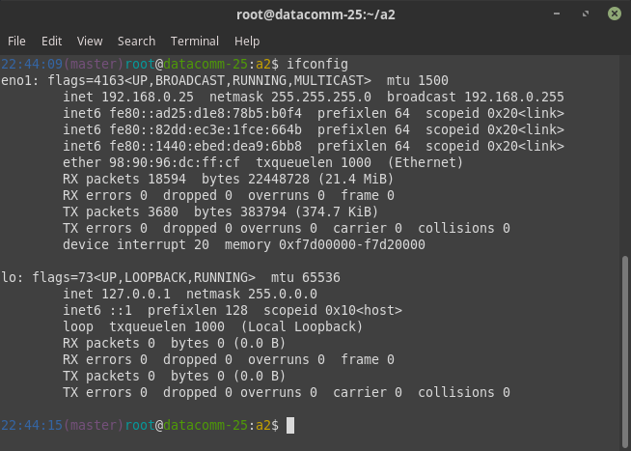

Test SSH in - Connected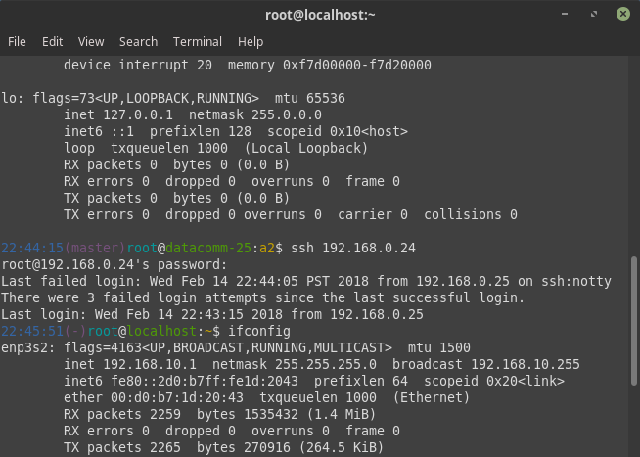

Outbound testing